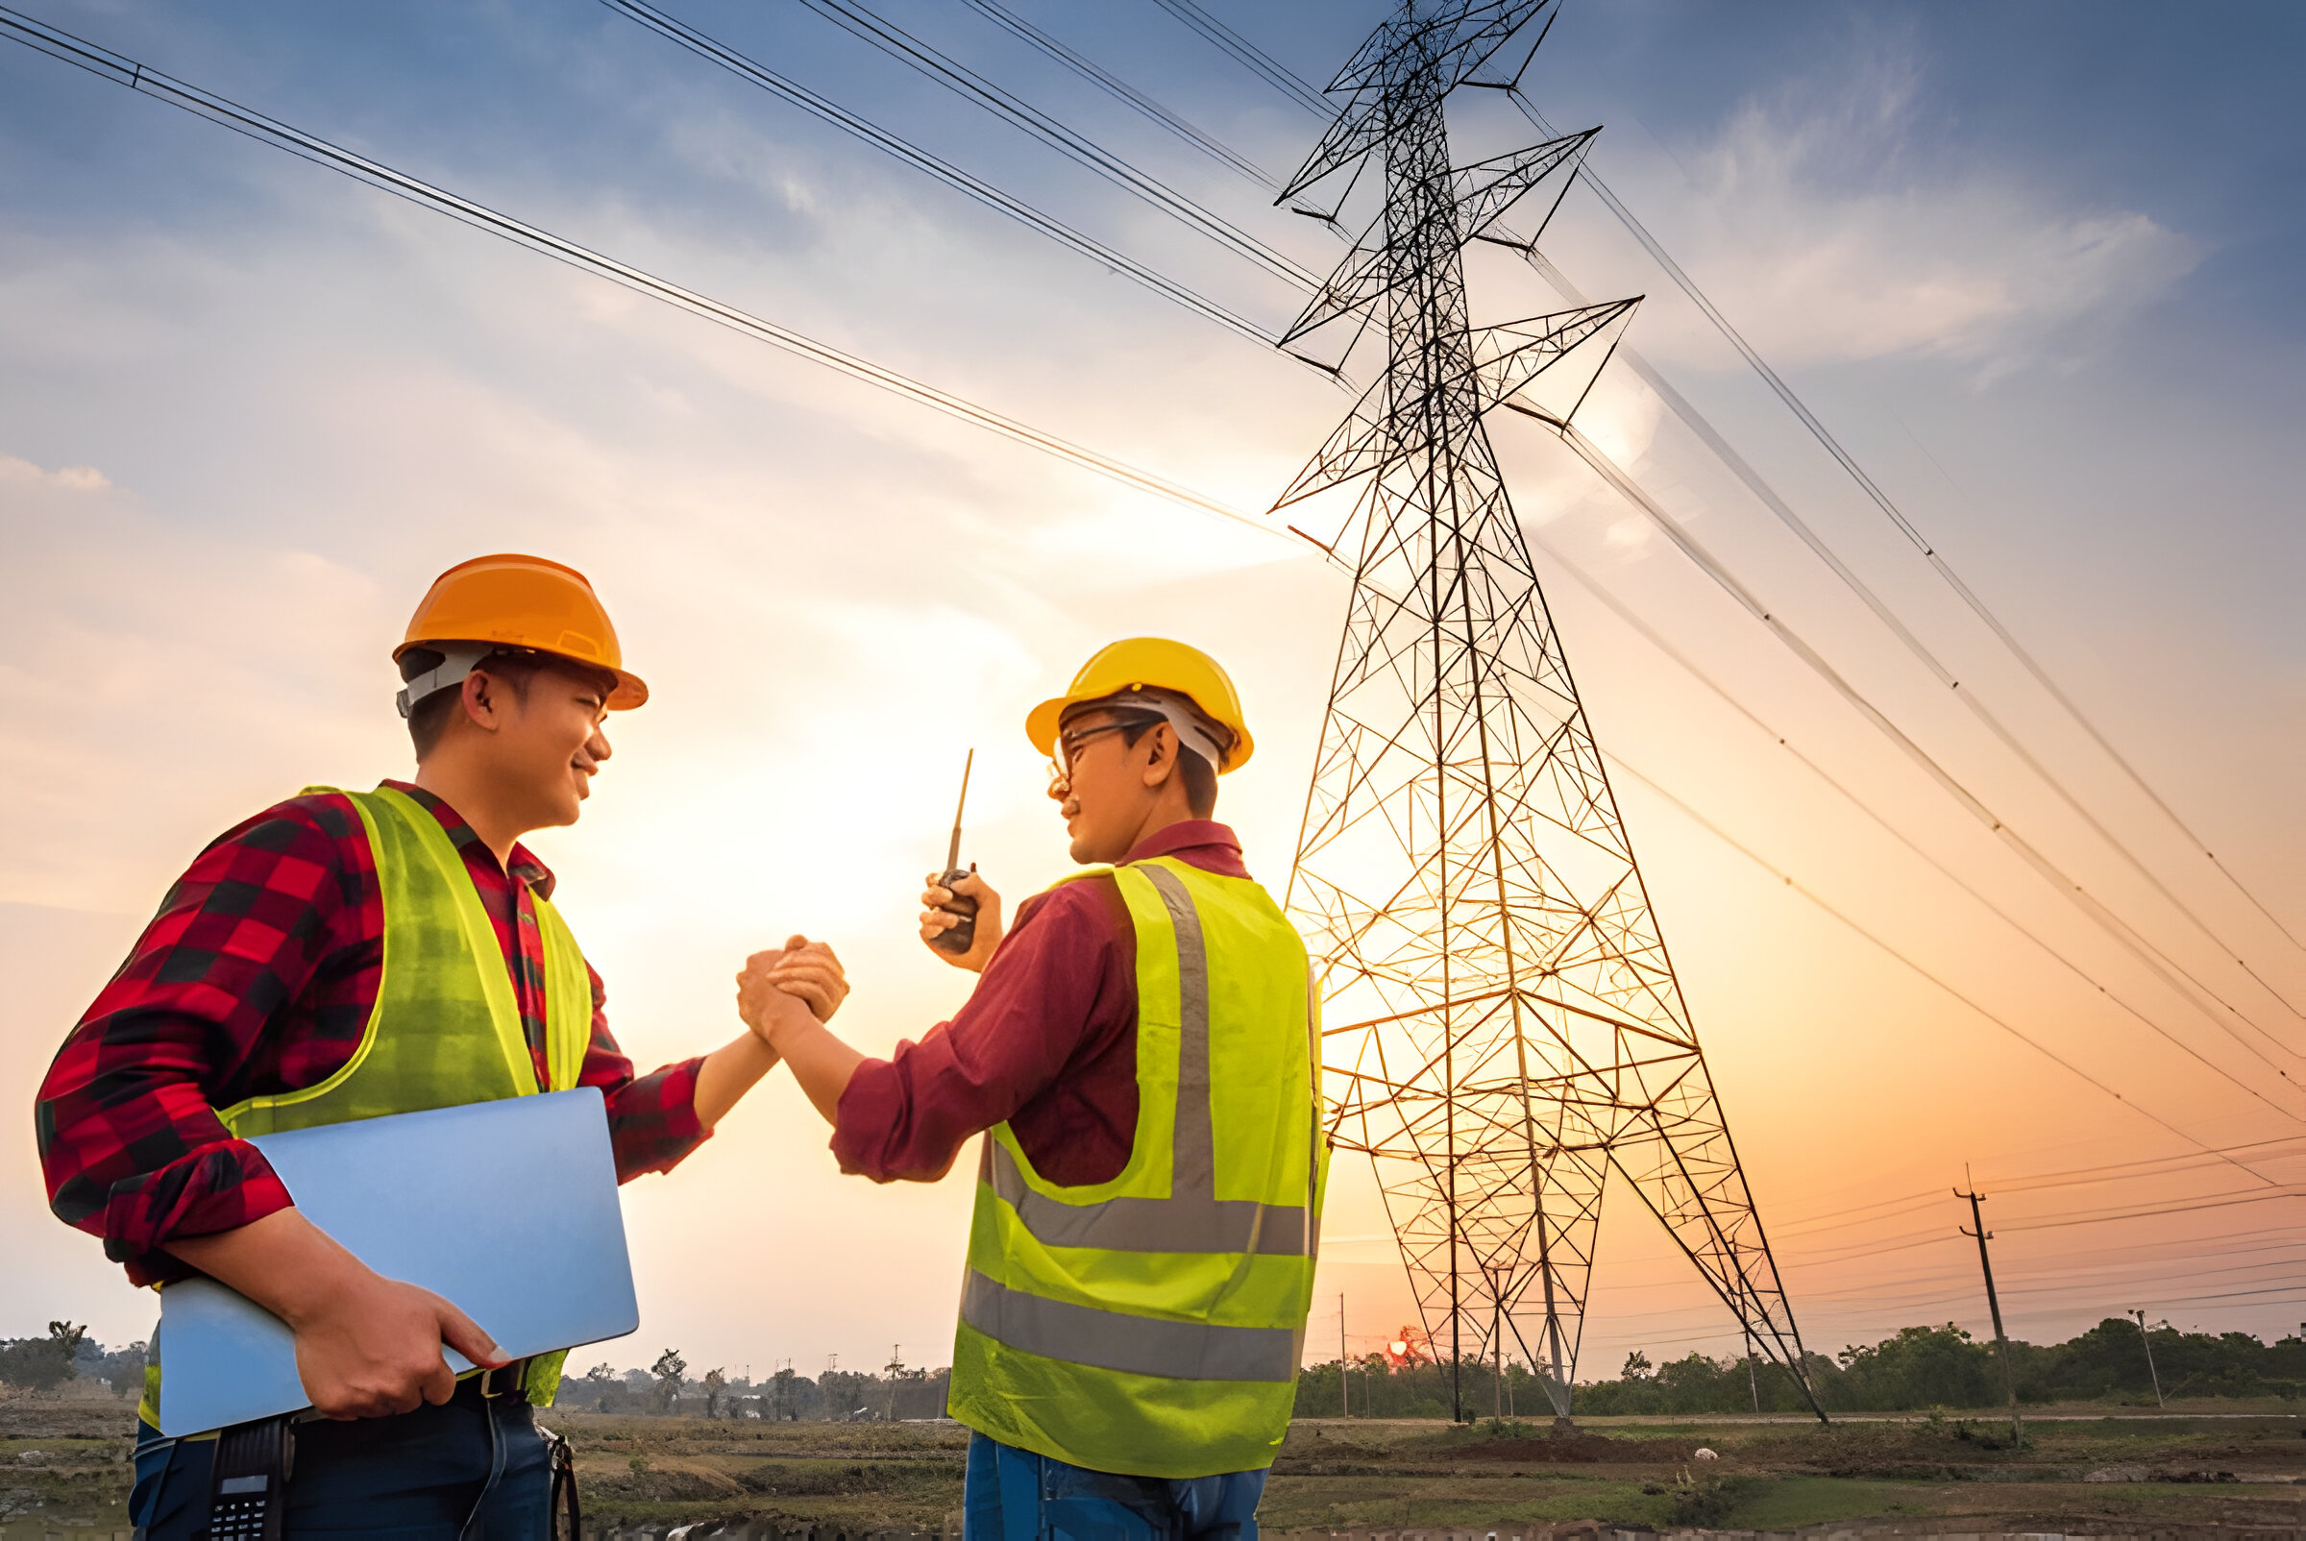

consulting

sales

staffing

support



The firm regularly supplies, Installation, Testing, Commissioning, and services to “MSEDCL Co.”,” Zilla Parishad Nashik” and ”PWD” for various APDRP and Infra projects and fully, and partial Trunkey projects in Maharashtra. We also given the services to Private sectors, Builders, and Industries. The firm has already turned out 50 Lakh up to 31.03.2024 and the targeted sales for the financial year 2024 to 2025 is Rs. 1 crores.

WE WORK WITH CLIENTS WITH A KEEN DESIRE TO BUILD MUTUAL TRUST.

Prasanna Electrical Engineering services is established by Director, **Mr. Bhushan R Thorat** in year 2021. A technology driven company and is registered as “A” Class Electrical Contractor. We are primarily a contractor and undertake all types of electrical contracts and turn-key projects in Industries, Commercial Complexes, Banks, IT Parks, Shopping Malls and Government Organizations. Besides we provide maintenance services for electrical equipment’s and installations. Our company has trained manpower and vast experience in the field of LT and HT electrical installations.

We will be highly obliged if you give us the opportunity to work under your kind control and assure you our best services. Working for corporate client like you will be adding a stars in our profile keeping this in mind we will never compromise on given work. With the hope of positive response waiting eagerly to serve you and look forward for your kind consideration.

MR.BHUSHAN R.THORAT

PRASANNA ELECTRICAL PROPRIETOR

# **ABOUT PRASANNA ELECTRICAL**

OUR SERVICES

OUR CLIENTS

## ERRECTION OF HT & LT CABLING

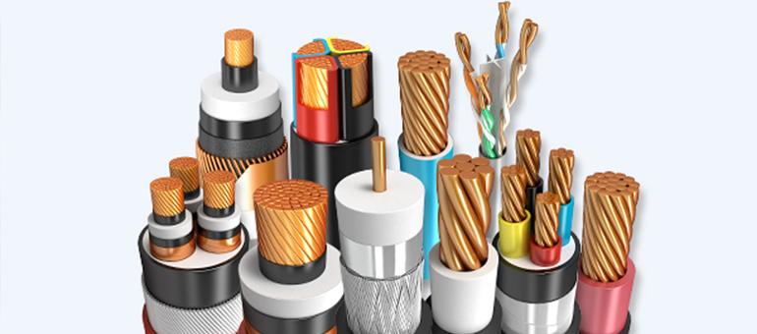

M/s. Prasanna Electrical Engg.Services has earned a good name in HT/LT Lines, DTC & Cabling work as a dedicated and professionally managed marketing organization. We have a vast domain expertise in Errection of all types of Cabling work in dimensions as per client’s requirements. We use industrial heavy duty flexible cables and HT/LT Power control cables.

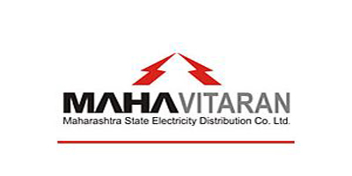

MSEDCL

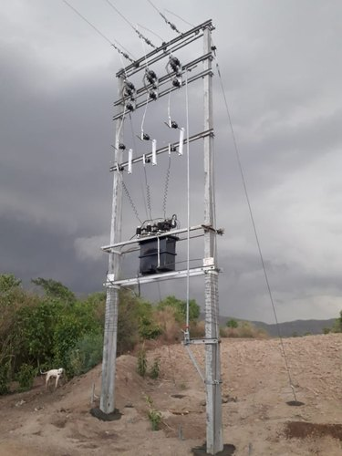

## Supply And Erection OF DTC, HT & LT

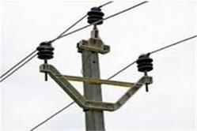

ZP NASHIK

PWD

We are a service provider of Electrical Material Supply & Errection to our clients. We are known for installation of Distribution Transformer Pole Mounted Structure , HT/LT line, Aerial Bunch, High Mast Light Pole Streetlights for MSEDCL (MSEDCL Licening) in all over Maharashtra.

## Solar Rooftop (Instalation/Sales/Service)

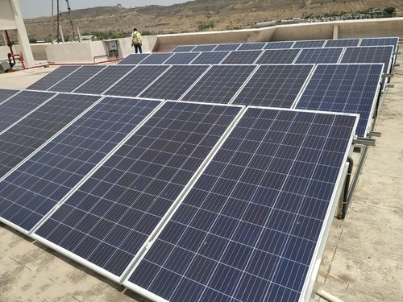

We are offering highly reliable Solar Rooftop Installation Services. We are deal with ON-GRID, OFF-GRID, HABRID SOLAR SYSTEM. Our experts check all the parameters and actual calculations as per residential load to this installation service This service is widely urged in various sectors and performed using the best grade tools and advanced techniques. Our experts check all the parameters associated to this installation service and execute it in an excellent manner.



**Advantages:**

1. It is a secure investment

2. Reduce or eliminate energy bills.

3. Earn tax credits and rebates.

4. Help the environment and help us all.

**The Solar Rooftop are used in following areas:**

1. At Home

2. At Company

3. Solar company

## Solar Net Metering

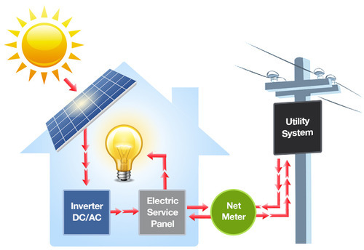

Net metering is a mechanism which allows domestic or commercial users who generate their own electricity using solar panels or photovoltaic systems to export their surplus energy back to the grid.

**Advantages:**

1. Reduced electricity bills.

2. Benefit for the environment.

3. Preserves natural energy resources.

4. No need to install expensive battery storage system.

5. Take some pressure off electric grids.

5. Encourages customers to move towards renewable energy.

## Solar Water Pump

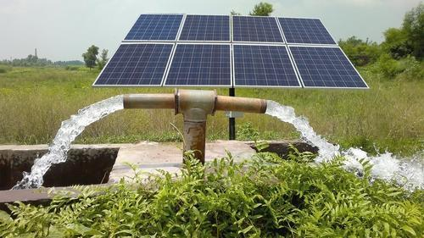

A solar water pump is an entire water pumping system powered by solar energy through the use of solar photovoltaic panels. It does not use any fossil fuels or external electricity to run the pump. The pump is a traditional water pump that is generally used for irrigation purposes.

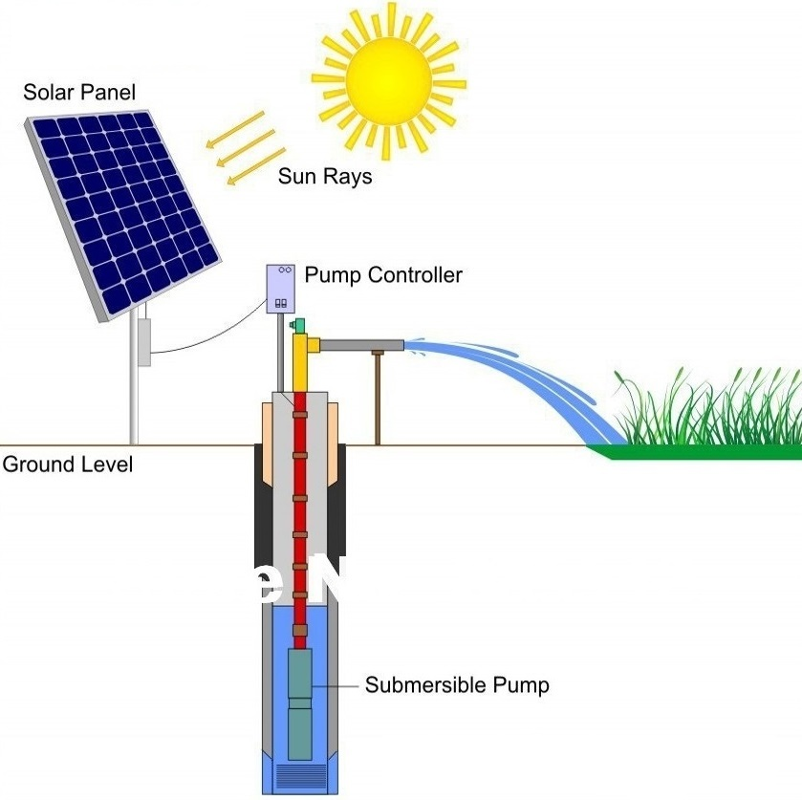

**Advantages:**

1. No fuel cost - as it uses available free sun light.

2. No electricity required.

3. Long operating life.

4. Highly reliable and durable.

5. Easy to operate and maintain.

5. Eco-friendly.

**The Solar Water Pump are used in following areas:**

1. At Farm area

2. Used to irrigate crops

3. USed for water livestock or provide potable drinking water.

## Solar Street Light With CCTV

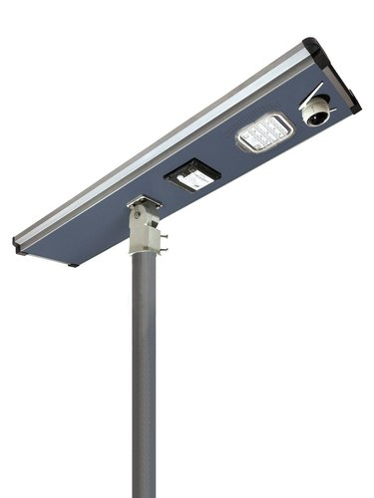

**Advantages:**

1. Energy-saving, pollution-reducing, money saving.

2. No cable-laying work or complicated power facilities needed!

3. No interdependency weaknesses

4. Intelligent control, easy construction and maintenance.

5. No cable costs, no cable theft.

**The Solar Street Light with CCTV are used in following:**

1. Used as solar Street light at Street side road

2. At Home

Solar street lighting system uses the photovoltaic technology to convert the sunlight into DC electricity through solar cells. The generated electricity can either be used directly during the day or may be stored in the batteries for use during night hours.

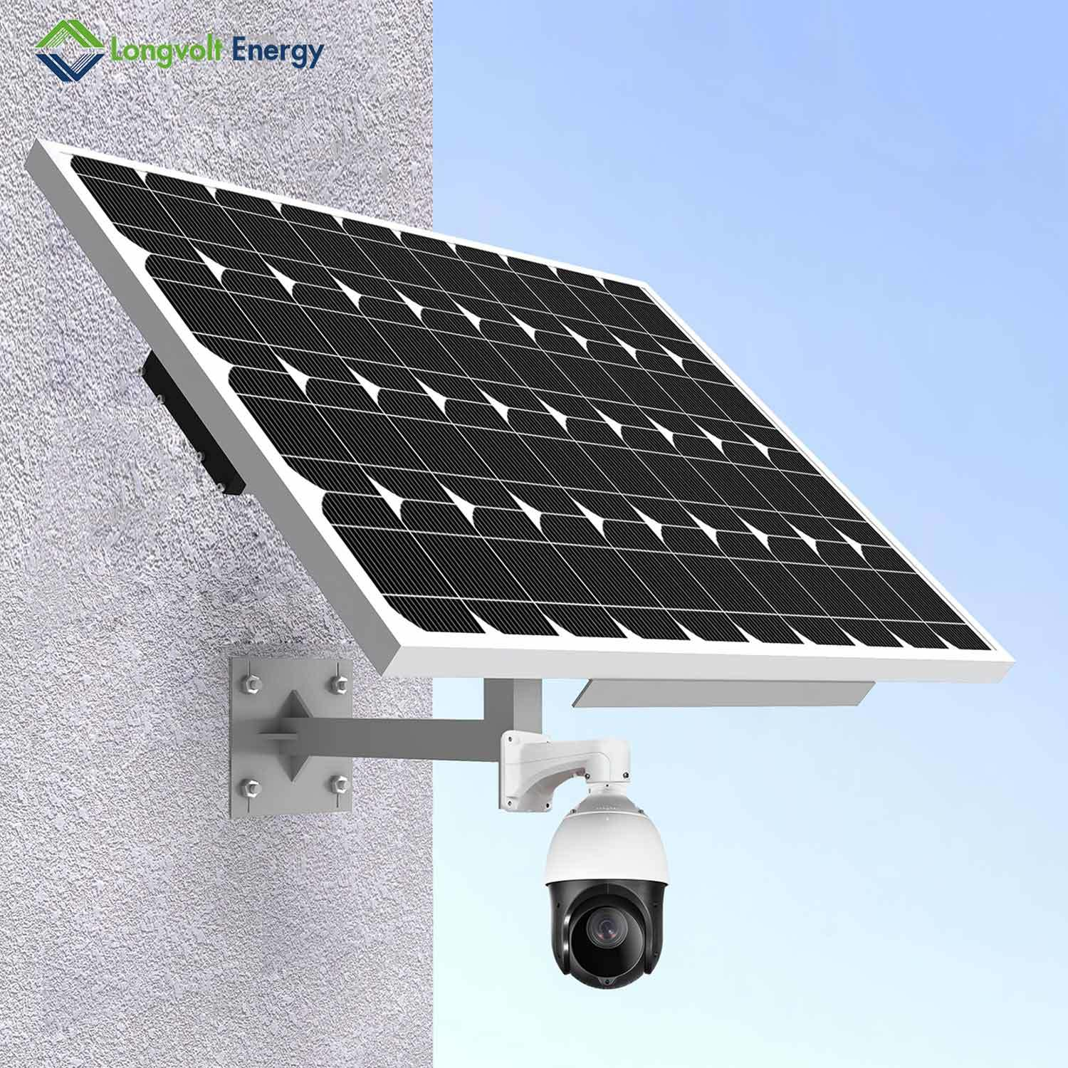

## pole erection machine



Prasanna Electrical is used to be very suitable in digging earth for pole for one to two minutes & erection of Electrical Poles within 10minutes. This compact solution can be quite useful for Pole erection with 3-5 labours and increases the number of poles erected per day thereby significantly reducing the project time drastically. More safeties are provided in this machine compare to other local pole erector machines.

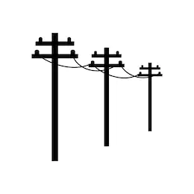

**Features:**

* Easy to operate
* High working efficiency
* Longer working life
* Capacity-1500kg
* Drill Diameter- 6inch to 30 inch
* Product Type- Hydraulic Operated
* Drilling Depth-1feet to 7feet



Contact us

PRASANNA ELECTRICAL ENGINEERING SERVICES

**Work-**

Ajmir Saundane Rd,Bramhangaon, Baglan, Satana, Nashik, Maharashtra, 423213

**Office-**

Atharva Computer, Taharabad Naka, Baglan, Satana, Nashik, Maharashtra, 423203



+91-9529099059

prasannaelectrical1@gmail.com